 Wisconsin Green Industry Federation

January 30, 2009

Pam Linn, President
Wisconsin Chapter of the American Society of Landscape Architects (WIASLA)

Dear Pam,

Thank you for working with us to arrive at a compromise with your proposed bill. WGIF supports the draft bill LRB-0547/2, which incorporates the changes we sought to insure that professionals in the landscape trades would not be prevented from engaging in related design, construction and installation activities.

Please understand that if any unintended consequence should arise as a result of this bill that ill-affects the businesses or professionals in the landscape industry, WGIF will pursue any necessary amendments or changes to the law.

Thank you.

Sincerely,

Wisconsin Green Industry Federation
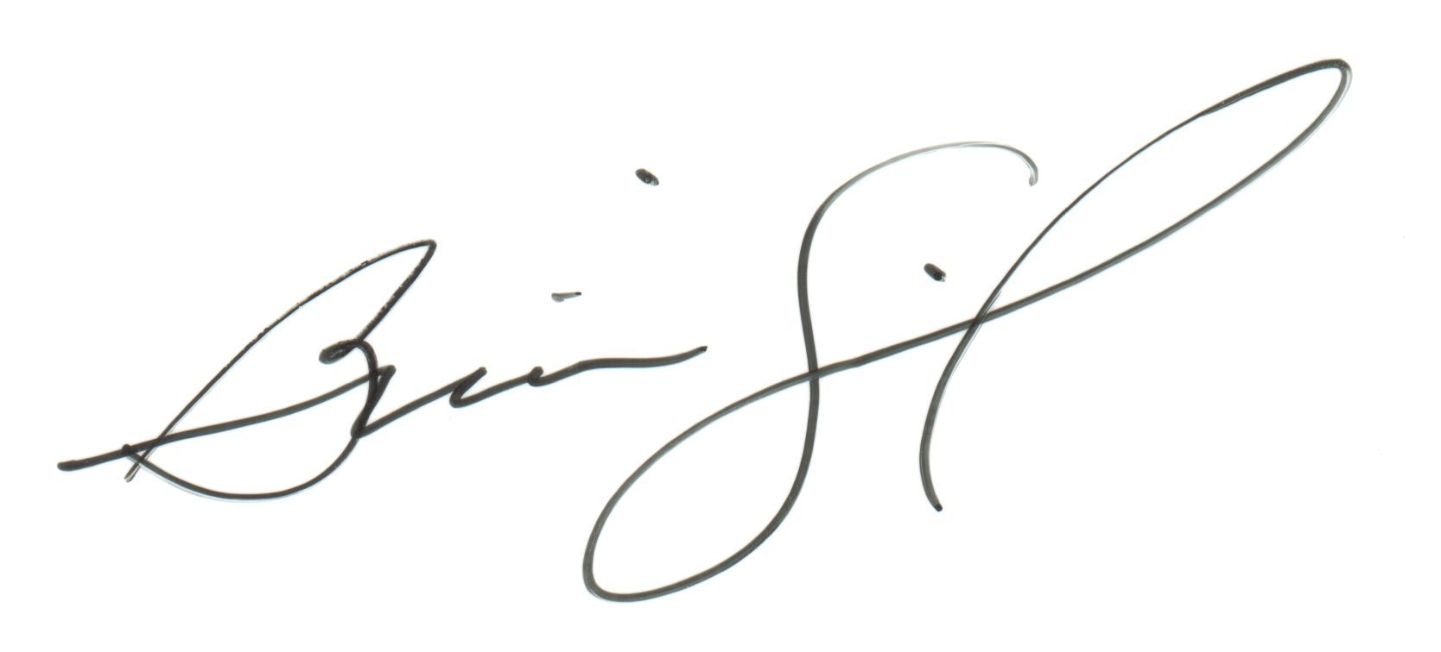
Brian Swingle
Executive Director

Cc: Sen. Fred Risser
Rep. Tom Lothian
Rep. Mark Honadel

